3-day training in
Therapeutic Storywriting Groups

What is Therapeutic Storywriting?
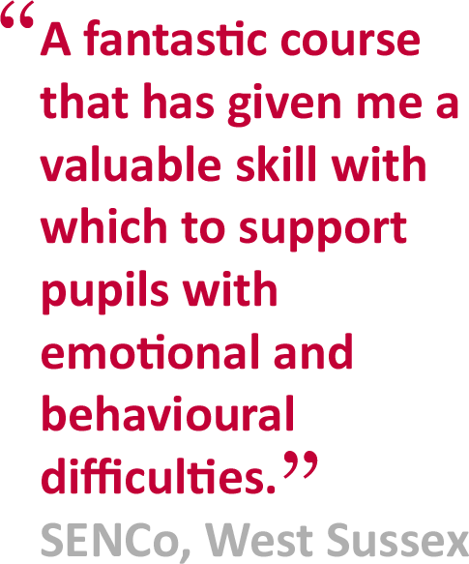
Therapeutic Storywriting uses the metaphor in stories to support children whose emotional and behavioural difficulties are getting in the way of their learning.
Research shows that the 10-week intervention improves pupils’ writing skills while also developing their emotional and social skills.
Therapeutic Storywriting is a DfE example of good inclusive practice (SEN IMPACT: Case Study 14) and used in over 35 LAs in the UK.

Is this training right for me?
This course is aimed at SEN teachers, learning mentors, teaching assistants, school counsellors and other professionals supporting emotionally anxious children at Key Stages 2 & 3.
Next training session:  Dates: Tuesdays 5 May, 2 June & 7 July 2020  Cost: £395  Venue: Quadrant Court, 35 Guildford Road, Woking,GU22 7QQ | Booking:  To apply for a place on the course, please complete the booking form overleaf.
About the trainer:  Anne Henderson is a Specialist Behaviour Teacher in South West Surrey. | Delivered in collaboration with:

BOOKING FORM
Name of training: Therapeutic Storywriting
Dates of training: 5 May, 2 June & 7 July 2020
Start time 09.30am – End time 15.30pm.
Location of training: Surrey County Council, Quadrant Court, 35 Guildford Road, Woking, Surrey, GU22 7QQ
Please complete and return this booking form to: Anne Henderson  Post: SW Education Team, Quadrant Court, 35 Guildford Road, Woking GU22 7QQ  Email: anne.henderson@surreycc.gov.uk | Cost: £395 per delegate  Confirmation:  Your place will be confirmed within 2 weeks of your booking request.
Member of Staff’s Name: | Position:
School Name:  Address: |  | School SAP Org No:  If n/a, please specify payment details
Telephone number: | Personal mobile no:
E-Mail:
Please note: All details concerning the course will be sent to this email address.
Refreshments will be provided however candidates should provide their own lunch. | Special access requirements?  Give details.
Local authority:

