3-day training in
Therapeutic Storywriting Groups

What is Therapeutic Storywriting?
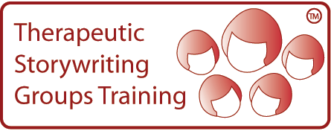
Therapeutic Storywriting uses the metaphor in stories to support children whose emotional and behavioural difficulties are getting in the way of their learning.
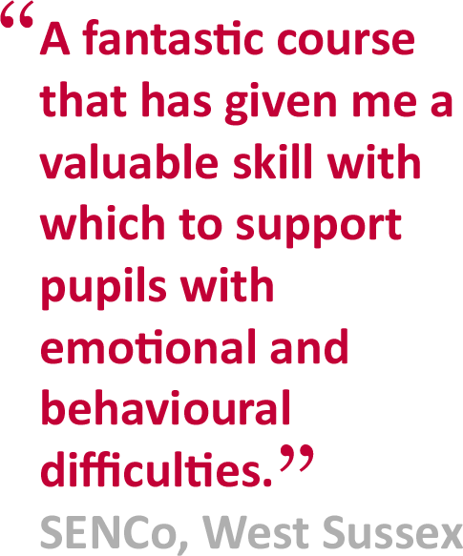
Research shows that the 10-week intervention improves pupils’ writing skills while also developing their emotional and social skills. Therapeutic Storywriting is a DfE example of good inclusive practice (SEN IMPACT: Case Study 14) and is used in over 35 Local Authorities

Is this training right for me?
This course is aimed at SEN teachers, learning mentors, teaching assistants, school counsellors and other professionals supporting emotionally anxious children at Key Stages 2 & 3.

Next training session:  Dates: 29/1/19; 26/2/19; 26/3/19  Cost: £350  Venue: DLC Spennymoor | Booking:  To apply for a place on the course, please complete the booking form below/overleaf.
About the trainer:  Joanne Watson is the Senior Behaviour Support Worker for the Emotional Wellbeing and Effective Learning Team. | Delivered in collaboration with:
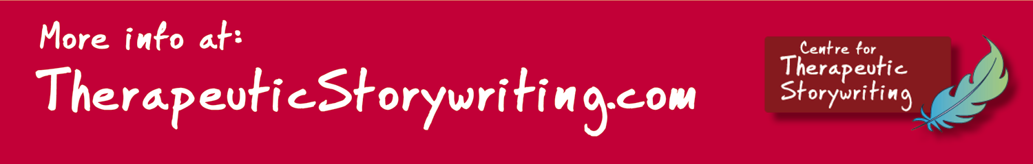

BOOKING FORM
Name of training: Therapeutic Storywriting Groups
Dates of training: 9.15am – 3.30pm
Location of training: Durham Leadership Centre, Enterprise Way, Spennymoor, DL16 6YP. Telephone: 03000 263306/07
Please complete and return this booking form to:  Post: Cherri Rickaby  School Courier:  Email: cherri.rickaby@durham.gov.uk  Fax: 01740 657792 | Cost: £350 per delegate  Refunds: minimum of 2 weeks’ notice  Confirmation: via email to secure server  Please contact [name] on if you have not received confirmation of your place by [date]
Member of Staff’s Name: | Position:
School Name:  Address: |  | School SAP Org No:  If n/a, please specify payment details
Telephone number: | Personal mobile no:
E-Mail:
Please note: All details concerning the course will be sent to this email address.
Special dietary requirements, e.g. vegetarian? Give details: | Special access requirements?  Give details.
Local authority:

