Therapeutic Storywriting Research Findings
Led to:
- A significant reduction in levels of anxiety.
- Significant improvements in verbal working memory.

(Holder, 2015)

Led to significant improvements in pupils’:
- Optimism (helping pupils to feel more optimistic) and Recovery (how quickly they are able to recover from feeling upset).
- Conduct Problems, Emotional Difficulties, Hyperactivity and Friendships.
- Pupil confidence.
- Children were more willing to work independently and put forward more creative ideas.
(Batchelor, Warhurst, Nuttall & Bradley, 2014)

Enabled pupils to:
- Develop cooperative and trusting relationships with their peers.
- Process their emotional experiences.
There were also significant improvements in:
- Pupil’ motivation to write.
- Listening skills.
- Confidence in their own ideas.
(Waters, 2002, 2008)

Led to significant improvements in pupils’:
- Emotional vocabulary.
- Sense of Belonging.
(Harris, 2013)
Led to:
- Significant academic gains in terms of pupils’ writing achievement; some children in the intervention group made as many as three national curriculum sublevels improvement.
- An increase in pupils’ use of emotional vocabulary which indicates a development in pupils’ understanding of emotions.
(Maclean, 2013)

Therapeutic Storywriting (TSW) uses the metaphor in stories to support children whose emotional and behavioural difficulties are getting in the way of their learning.
Research shows that the 10-week intervention:

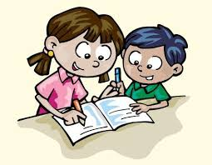

Therapeutic Storywriting is a DCSF example of good inclusive practice (SEN IMPACT: Case Study 14).

Is this training right for me?
This course is aimed at SEN teachers, learning mentors, ELSAs, teaching assistants, school counsellors and other professionals supporting emotionally anxious children in years 2-9.

