3-day training in
Therapeutic Storywriting Groups

What is Therapeutic Storywriting?
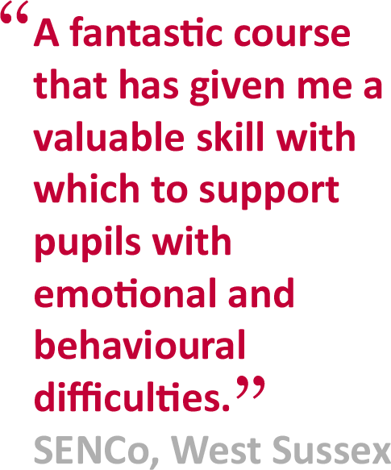
Therapeutic Storywriting uses the metaphor
in stories to support children whose
emotional and behavioural difficulties are
getting in the way of their learning.
Research shows that the 10-week intervention
improves pupils’ writing skills while also
developing their emotional and social skills.
Therapeutic Storywriting is a DCSF example of
good inclusive practice (SEN IMPACT: Case Study
14) and is in use in over 35 LAs in the UK.

Is this training right for me?
This course is aimed at SENCo’s, teachers, learning mentors, teaching assistants and other professionals supporting emotionally anxious children at Key Stages 2 & 3.
Next training session:  Dates: Wednesday 7th June, Wednesday 29th June  and Wednesday 19th July 2017  Cost: £400 per delegate  Venue: TBC | Booking:  To apply for a place on the course, please  complete the booking form below/overleaf.
 | Delivered in collaboration with:
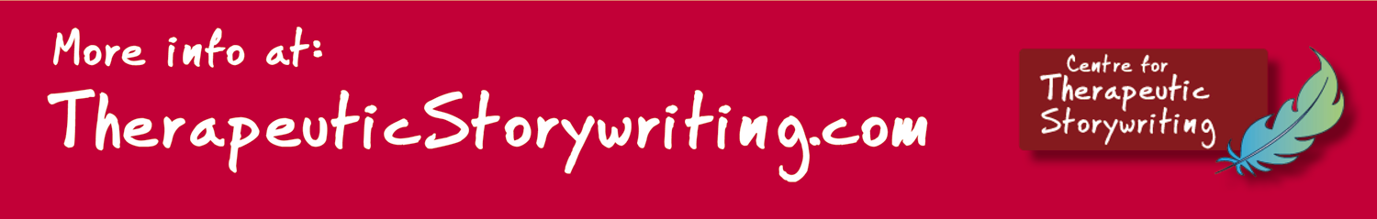

BOOKING FORM
Name of training:
Dates of training:
Location of training:
Please complete and return this booking form to:  Post:  School Courier:  Email:  Fax: | Cost: £400 per delegate  Refunds:  Confirmation:  Please contact [name] on if you have not received confirmation of your place by [date]
Member of Staff’s Name: | Position:
School Name:  Address: |  | School SAP Org No:  If n/a, please specify payment details
Telephone number: | Personal mobile no:
E-Mail:
Please note: All details concerning the course will be sent to this email address.
Special access requirements?
Give details.

Local authority:

