

**Who is this course for?**

A training course for SENCos

SEN Teachers Teaching Assistants

School Counsellors

Educational Psychologists

Mental Health Workers and other Professionals

**3 Day Course – Cost: £395**

Including a copy of Trisha Waters’ book and all printed materials

Please bring your own lunch

**How to Book**

**Contact: Pat Barnes**

Tel: 01452 328075

Email: pat.barnes@gloucestershire.gov.uk

*An* ***accredited 3 day training course*** *to support children with emotional, social and behavioural needs through their own storywriting*

**Delivery by Julie Higginson, Educational Psychologist (Licensed Therapeutic Storywriting Trainer)**

**When and Where?**

**9.30am - 3.30pm**

**(Tea & Coffee @ 9.00am)**

**Day 1: 3 October 2017**

**Day 2: 31 October 2017**

**Day 3: 28 November 2017**

Battledown Centre

Harp Hill

Battledown

Cheltenham   
Gloucestershire

GL52 6PZ

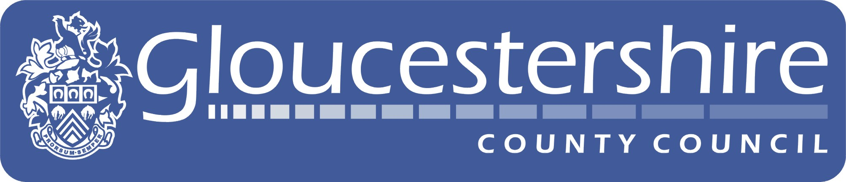

**Gloucestershire**

**Educational**

**Psychology Service**

**Training Courses**

***There is an expectation that participants will run a small weekly group throughout the training***

**Therapeutic Storywriting**

The approach provides a non-threatening way to process difficult feelings while also developing the child’s writing skills. Evidence based research has shown that Therapeutic Storywriting Groups can lead to a significant improvement in both children’s emotional resilience and their confidence with storywriting. The model has been used by the DfES as an example of best practice to support inclusion (SEN Impact: Case Study 14)

[www.therapeuticstorywriting.com](http://www.therapeuticstorywriting.com)

**Therapeutic Storywriting Training**