3-day training in
Therapeutic Storywriting Groups

What is Therapeutic Storywriting?
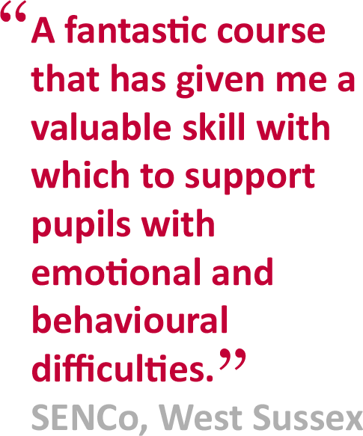
Therapeutic Storywriting uses the metaphor
in stories to support children whose
emotional and behavioural difficulties are
getting in the way of their learning.
Research shows that the 10-week intervention
improves pupils’ writing skills while also
developing their emotional and social skills.
Therapeutic Storywriting is a DCSF example of
good inclusive practice (SEN IMPACT: Case Study
14) and is in use in over 35 LAs in the UK.

Is this training right for me?
This course is aimed at SEN teachers, learning
mentors, teaching assistants, school
counsellors and other professionals
supporting emotionally anxious children at
Key Stages 2 & 3.
Next training session:  Dates: 03/10/17; 01/11/17; 05/12/17  Cost: £350  Venue: DLC Spennymoor | Booking:  To apply for a place on the course, please complete the booking form below/overleaf.
About the trainer:  Joanne Watson is the Senior Behaviour Support Worker for the Emotional Wellbeing and Effective Learning Team. | Delivered in collaboration with:

BOOKING FORM
Name of training: Therapeutic Storywriting Groups
Dates of training: 3 full days - Tues 3rd Oct, Wed 1st Nov & Tues 5th Dec 2017. 9.15am – 3.30pm
Location of training: Durham Leadership Centre, Enterprise Way, Spennymoor, DL16 6YP. Telephone: 03000 263306/07
Please complete and return this booking form to:  Post: Cherri Rickaby  School Courier:  Email: cherri.rickaby@durham.gov.uk  Fax: 01740 657792 | Cost: £350 per delegate  Refunds: minimum of 2 weeks’ notice  Confirmation: via email to secure server  Please contact [name] on if you have not received confirmation of your place by [date]
Member of Staff’s Name: | Position:
School Name:  Address: |  | School SAP Org No:  If n/a, please specify payment details
Telephone number: | Personal mobile no:
E-Mail:
Please note: All details concerning the course will be sent to this email address.
Special dietary requirements, e.g. vegetarian? Give details: | Special access requirements?  Give details.
Local authority:

